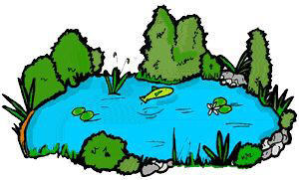
Spanish in la laguna

Here are the two songs that we have practiced in Spanish class. We learned what the words mean through actions and translation. Students have not seen these videos. Just wanted to send them home so that students can teach you the songs or use some of what they are learning in Spanish at home.

Youtube: http://www.youtube.com/watch?v=JZ1sScollwY
Youtube: http://www.youtube.com/watch?v=oqxpMeMFxcA

El sapito en la laguna
The little toad in the pond

El sapito The Little toad
En la laguna in the pond
Salta y salta jumps and jumps
Sin cesar without stopping
Cuando Salta, When he jumps
Salta y salta He jumps and jumps
Va cantando su croar He goes singing his croak

Croar, croar croak, croak
Croar, croar croak, croak

El sapito The Little toad
Se ha encontrado has found
Con una sapita verde a Little Green female toad
Y croando con el sapo and croaking with the toad
Salta, salta She jumps, she jumps
Y se divierte and has fun
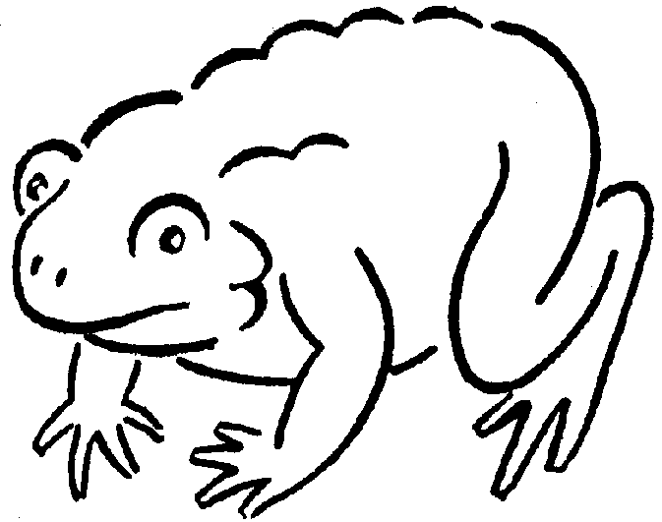

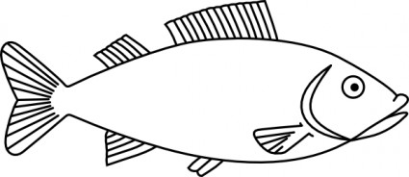
Diez pecesitos
Ten Little fish

Diez pecesitos Ten Little fish

Nadando en el río Swimming in the river
Rojo, verde, azul y amarillo red, Green, blue and yellow
Estaban jugando They were playing
y uno se cansó and one got tired
Me voy a dormir I’m going to sleep
Y se retiró And it went away

Nueve pecesitos… Nine Little fish

Ocho pecesitos… Eight Little fish

Siete pecesitos… Seven Little fish

Seis pecesitos… Six Little fish

Cinco pecesitos… Five Little fish

Cuatro pecesitos… Four Little fish

Tres pecesitos… Three Little fish

Dos pecesitos… Two Little fish

Un pecesito One Little fish
Todo cansadito All tired
Se fue a su cama went to his/her bed
Tan solito So alone
Ya durmiendo already sleeping
Comenzó a soñar It started to dream
Que los amigos querían jugar That his friends wanted to play

